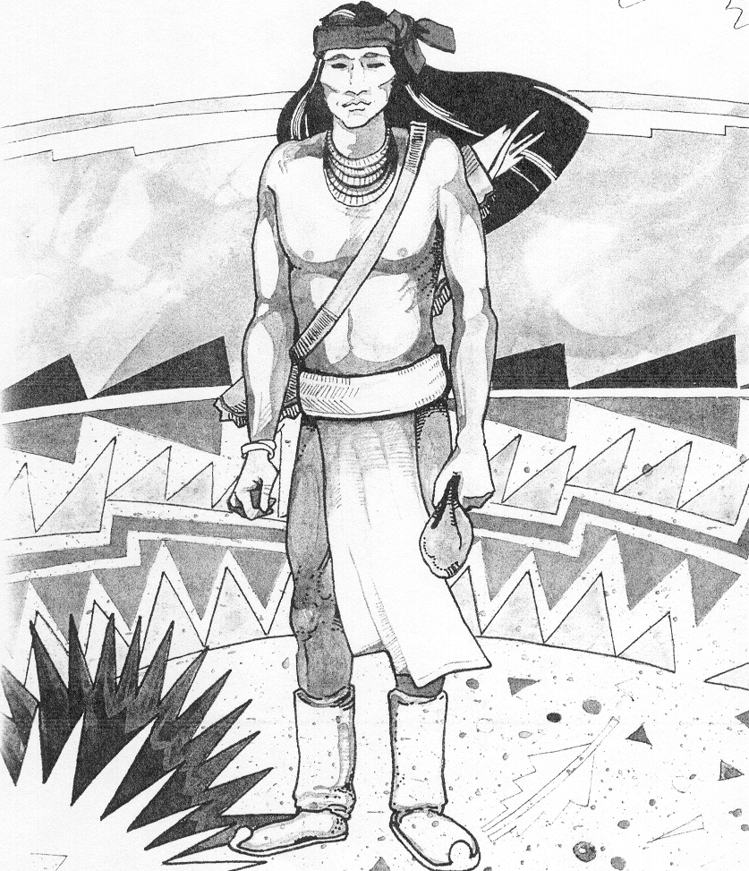
Cochise School District No. 26

5025 N. Bowie Ave.
P.O. Box 1088
Cochise, AZ 85606
(520) 384-2540 (520) 384-4836 Fax

Karl O. Uterhardt, Superintendent

PUBLIC SERVICE ANNOUNCEMENT

August 2, 2021

Screening and referrals for children aged birth through 21 years of age, who may have disabilities or significant developmental delays, is available for children within the geographical boundaries of the Cochise School District No. 26.
These services are provided through Child Find. Child Find is a federally-mandated screening program.
Parents or guardians of such children are invited to call Cochise School at (520) 384-2540 to arrange an appointment for a free Child Find screening.
The next Child Find screenings are scheduled for the following dates: September 15, October 13, November 17, and December 13, 2021 from 9:00 am to 10:00 am.

###

For additional information, please contact:
Cochise School (520) 384-2540

